Design Procedure for Riveted Boiler Joints
Longitudinal Joint: Butt Joint

- Type of Joint: If the type of joint is not given, select the type of joint from Table 5.2/Pg.84 based on the diameter of the shell.
- Determine the thickness of shell joint
$t=\frac{p_{i}D}{2σ_{t} η}+1 mm$
Eqn5.1/Pg.79 with a modification of corrosion allowance of 1mm
If the efficiency is not specified, the efficiency may be obtained from Table 5.1/Pg.84
Where p_{i} = Pressure acting inside the boiler, N/mm²
D= Internal diameter of pressure vessel, mm
σ_{t} = Allowable tensile stress of shell plate , N/mm²
η = Efficiency of longitudinal joint
Recommended type of Joints based on D and t
The standard value of plate thickness is to be selected from the Table 5.3(c)/Pg.85

- Determine the diameter ,d, of the rivet hole from Unwin’s formula
- If the thickness of the plate is more than 8mm (t > 8 mm) the diameter of rivet hole is obtained from Unwin’s formula
$d=6.07\sqrt{t}$ Eqn5.11 (d) /Pg.81
- If $t≤8mm$, diameter should be calculated by equating the shearing resistance of the rivets to the crushing resistance
$$P_{s}=P_{c}$$
$\left(n_{1}+1.875n_{2}\right)\left[\frac{πd^{2}}{4}\right]τ=\left(n_{1}t_{i}+n_{2}t\right)dσ_{c}$ Eqn5.6 (d&e) /Pg.80

$d=\frac{4\left(n_{1}t_{i}+1.875n_{2}t\right)}{π\left(n_{1}+1.875n_{2}\right)}×\frac{σ_{c}}{τ}$ Eqn 5.10(a) /Pg.81
For lap joint t_{i} =t and n₂ =0
For equal cover butt joint n₁ =0

Select the diameter of rivet, d_{r}, from Table.5.3 (b) page 84
Or
d = d_{r} + 1 for 12 mm < d < 24 mm
d = d_{r} + 1.5 for 24 mm < d < 36 mm
d = d_{r} + 2 for d > 36 mm
Note: Use diameter of rivet hole for all calculations

- Determine the pitch of rivets
- The pitch of the rivets is obtained by equating the shearing resistance of the rivets to the tearing resistance of the plate
$$P_{s}=P_{t}$$
$\left(n_{1}+1.875n_{2}\right)\left[\frac{πd^{2}}{4}\right]τ=\left(p-d\right)tσ_{t}$ Eqn5.6 (d&b) /Pg.80
Optimum pitch
$p=\frac{\left(n_{1}+1.875n_{2}\right)πd^{2}τ}{4tσ_{t}}+d$ Eqn 5.12(a) /Pg.81
For lap joint n₂ =0
For equal cover butt joint n₁ =0
- Maximum pitch, $p_{max}=k_{1}t+41 mm$ Eqn5.12 (b) /Pg.81
Where k₁ = a constant Table 5.4(a)/Pg.85
Adopt lower value of pitch, p.
- Determine the transverse pitch ( distance between rows of rivets
It can be calculated from the appropriate equations 5.14 (a) to (d) /Pg.82 & Eqn 5.15 (a &b)/Pg.82 and 83
- Determine the diagonal pitch for staggered joint
$p_{d}≥\frac{\left(p+d\right)}{2}$ Eqn5.17 (a) /Pg.83

${ p}_{d}=2.25d to 2.5 d$ Eqn5.17 (b) /Pg.83

- Determine the thickness of the cover straps from the appropriate equations given in Eqns 5.4 (a to f)/Pg.79 & 80

8. Determine the margin, m = 1.5 d Eqn5.16 /Pg.83

- Efficiency
$$η=\frac{least value of P_{t},P_{s} and P_{c}}{P}$$
The above procedure may also be used for ordinary riveted joint

Circumferential Joint: Lap Joint
1. The thickness of shell plate, diameters of rivet and rivet holes and margin are same for both longitudinal and circumferential joint.

2. Total steam load $P=\frac{π}{4}D^{2}p_{i}$

3. Strength of each rivet
In shear ${ P}_{s}=\frac{π}{4}d^{2}τ$
In crushing $P_{c}=dtσ_{c}$

4 No of rivets required

$N=\frac{Total steam load P}{Miminum strength of rivetP_{s}orP_{c}}$
5. Pitch of rivets
$η=\frac{p-d}{p}$ Eqn5.9 (e) /Pg.83
Assume suitable value of efficiency Table 5.1/Pg.84
Or
Optimum pitch
$p=\frac{\left(n_{1}+1.875n_{2}\right)πd^{2}τ}{4tσ_{t}}+d$ Eqn 5.12(a) /Pg.81
For lap joint n₂ =0
Maximum pitch, p_{max} =k₁ t+41 mm Eqn5.1 (b) /Pg.81
Where k₁ = a constant (Table 5.4(a)/Pg.85

6. Number of rivets in one row, n
The circumferential length considering the boiler diameter, D and plate thickness is obtained as
$$circumferential length =π\left(D+t\right)$$
Considering the pitch and the number of rivets per row, n
$$circumferential length =np$$

$n=\frac{π\left(D+t\right)}{p}$
7. Number of rows
$Number of rows=\frac{N}{n}$

After determining the number of rows the type of joints such as single riveted or double riveted lap joint is selected. Adjust the number of rivets in each row and the pitch of rivets.

8. Determine the transverse pitch, p_{t} (distance between two rows of rivets)

9. Determine the overlap of the plate where the longitudinal and circumferential joints meet
Overlap = (Number of rows of rivet-1) p_{t} + 2 m
Where m = margin =1.5 d
10. Efficiency of circumferential joint

$$η=\frac{least value of P_{t},P_{s} and P_{c}}{P}$$
Note
- Table 5.1/Pg. 84 gives the values of efficiency of commercial boiler joints.
- Table 5.2/Pg. 84 gives the recommended type of joints based on diameter of boiler shell.
- Table 5.3(b) /Pg. 84 gives the nominal diameter of the rivets.
- Table 5.3(c) /Pg. 85 gives the thickness of plates.
- Table 5.4(b) /Pg. 85 gives the recommended values of rivet hole diameter, pitch and efficiency.
- Pressure vessels are designed based on a factor of safety of 5 as given under the note section of Table 5.6 /Pg. 85.
Q1
Design a double riveted longitudinal joint for a boiler shell whose inner diameter is 1600 mm and steam pressure is 2 MPa. The ultimate tensile, shear and crushing strength are 450,400 and 800 MPa respectively.
Solution
D = 1600 mm, p_{i} = 2 MPa = 2 N/mm², $σ_{u}=450 MPa$ , $τ_{u}=400 MPa,$ $σ_{uc}=800 MPa$

Since the allowable stresses are not given, take a factor of safety of 5 to obtain the values.
$σ_{t}=\frac{σ_{u}}{5}=\frac{450}{5}=90 MPa$ , $τ=\frac{τ_{u}}{5}=\frac{400}{5}=80 MPa$ , $σ_{c}=\frac{σ_{uc}}{5}= \frac{800}{5}=160 MPa$

Since the efficiency of the joint is not provided, from Table 5.2/Pg.84 the recommended joint for pressure vessel with internal diameter 1600 mm the type of butt joint may be double or triple riveted joint. Selecting the double riveted joint, its efficiency range is 72 – 82 %. Take the efficiency = 80 %.
Table 5.1/Pg.84.

- Thickness of the shell
$t=\frac{p_{i}D}{2σ_{t} η}+1 mm$ Eqn5.1/Pg.79
$$=\frac{2×1600}{2×90×0.8}+1=23.22 mm$$
From Table 5.3(c)/Pg.85, the standard value of plate thickness is 25 mm. t = 25 mm

- Diameter of rivet hole
Since the thickness is more than 8 mm, the diameter of rivet hole can be calculated from the Unwin’s formula, $d=6.07\sqrt{t}$ Eqn5.11 (d)/Pg.79

$$d=6.07\sqrt{t}=6.07\sqrt{25}=30.35 mm$$
From Table 5.3 (b)/Pg. 84, the nominal diameter of rivet (d_{r}) is 30 mm.

d= d_{r} + 1.5 for 24 mm < d < 36mm, dr = 30
Diameter of rivet hole = 30 +1.5 = 31.5 mm
- Pitch of rivets
The longitudinal joint of a boiler is a double riveted butt joint with two equal or unequal cover straps. Assuming two equal cover straps with equal width and thickness, the remaining computations can be made.

Optimum pitch
$p=\frac{\left(n_{1}+1.875n_{2}\right)πd^{2}τ}{4tσ_{t}}+d$ Eqn 5.12(a) /Pg.81
For equal cover butt joint n₁ =0
$$p=\frac{\left(1.875n_{2}\right)πd^{2}τ}{4tσ_{t}}+d=\frac{\left(1.875×2\right)π{\left(31.5\right)}^{2}×80}{4×25×90}+31.5=135.41 mm$$
- Maximum pitch, $p_{max}=k_{1}t+41 mm$ Eqn5.12 (b) /Pg.81
Where k₁ = a constant (Table 5.4(a)/Pg.85
From Table 5.1/Pg. 84, for double row butt joint with two cover plates, No.of rivets per pitch = 2. From Table 5.4(a)/Pg. 85, for the No.of rivets per pitch of 2, the Coefficient, k₁ for double butt strapped joints = 3.5
$$p_{max}=k_{1}t+41 mm=3.5×25+41 =128.5 \sim 128 mm$$
Since p_{max} is less than the calculated value the pitch of the joint p = 128 mm.
For leak free joint$p ≤6 d$
$\frac{128}{31.5}=4.06 <6$ Eqn5.12 (d)/Pg.82
Hence the joint is leak proof
- Transverse pitch (distance between the rows of rivet)
The transverse pitch for equal number of rivets in the rows and for staggered (zig- zag) riveting
${ p}_{t}≥0.33p+0.67d$ Eqn5.14 (b)/Pg.82

${ p}_{t}≥0.33p+0.67d=0.33×128+0.67×31.5=63.35 mm\sim 64 mm$
For longitudinal joint the minimum value of transverse pitch (ASME boiler code)
$$\frac{p}{d}=\frac{128}{31.5}=4.06$$
If $\frac{p}{d}>4$, $p_{t}=1\frac{3}{4}d +0.1\left(p-d\right)=1\frac{3}{4}×31.5+0.1\left(128-31.5\right)=64.78 \sim 65 mm$
- Diagonal pitch for staggered joint = 2.25 d to 2.5 d
- Thickness of the cover straps
Thickness of double butt strap of equal width having ordinary riveting Eqn5. 4 (c)/Pg.80
$$t_{i}=t_{0}=0.625 t=0.625×25=15.62\sim 16 mm$$
- Margin, m
$$m=1.5 d=1.5×31.5=47.25 mm$$
- Efficiency
$$η=\frac{least value of P_{t},P_{s} and P_{c}}{P}$$
- Tearing efficiency $η_{t}=\frac{p-d}{p}=\frac{128-31.5}{128}=75.4 \%$ Eqn5.9 (e)/Pg.81
- Shearing or rivet efficiency $η_{s}=\frac{\frac{π}{4}d^{2}\left(n_{1}+1.875n_{2}\right)τ}{ptσ_{t}}$ Eqn5.9 (f)/Pg.81
$$η_{s}=\frac{\frac{π}{4}×{31.5}^{2}\left(0+1.875×2\right)80}{128×25×90}=81.18\%$$
- Crushing efficiency
$$η_{c}=\frac{P_{c}}{P}$$
Where P_{c} = Resistance to crushing of rivets

${ P}_{c}=\left(n_{1}t_{i}+n_{2}t\right)dσ_{c}$ Eqn5.6 (e)/Pg.80

$$η_{c}=\frac{\left(n_{1}t_{i}+n_{2}t\right)dσ_{c}}{ptσ_{t}}=\frac{\left[0+2×25\right]31.5×160}{128×25×90}=87.5 \%$$

The efficiency is the least = 75.4 %

Q2. Design circumferential joint for the above problem
The circumferential joint is always a lap joint
- Type of joint: Double riveted lap joint with zig – zag riveting. Number of rivets = 2.
- The thickness of shell plate, diameters of rivet and rivet holes and margin are same for both longitudinal and circumferential joint.
- Thickness of plate = 25 mm, diameter of rivet hole = 31.5 mm, diameter of rivet = 30 mm, margin = 47. 25 mm
Number of rivets in single shear = n₁ =2, number of rivets in double shear = n₂ = 0.

- Number of rivets

$$N=\frac{Total steam load P}{Miminum strength of rivetP_{s}orP_{c}}$$
Based on P_{s}
$$N_{s}= \frac{\frac{π}{4}D^{2}p_{i}}{\frac{π}{4}d^{2}τ}=\frac{{1600}^{2}×2}{{31.5}^{2}×80}=66$$
Based on P_{c} $N_{c}=\frac{\frac{π}{4}D^{2}p_{i}}{dtσ_{c}} =\frac{\frac{π}{4}×{1600}^{2}×2}{31.5×25×160}=32$
Hence maximum of these values is the total number of rivets in circumferential joint.
N = 66
- Pitch
- Optimum pitch
$p=\frac{\left(n_{1}+1.875n_{2}\right)πd^{2}τ}{4tσ_{t}}+d$ Eqn 5.12(a) /Pg.81

$$p=\frac{\left(2+1.875×0\right) π×{31.5}^{2}×80}{4×25×90}+31.5 \sim 88 mm$$

- Maximum pitch, p_{max}=k₁ t+41 mm Eqn5.12 (b) /Pg.81

Where k₁ = a constant Table 5.4(a)/Pg.85

k₁ = 2.62 for lap joint with two rivets per pitch

$$p_{max}=2.62×25+41=106.5 mm$$

Standard pitch is the lower value p = 88 mm
- Number of rivets per row

$$n=\frac{π\left(D+t\right)}{p}=\frac{π\left(1600+25\right)}{88}=58$$
Number of rows N/n = 66/58 = 1.14
As the minimum number of possible row = 2, pitch have to be recalculated
Number of rivets per row = n = 66/2 = 33
Pitch $p=\frac{π\left(D+t\right)}{n}=\frac{π\left(1600+25\right)}{33}=155 mm$ which is more than the p _{max}.

Limiting the number of rows = 2, Increasing the total number of rivets = N = n x 2 = 58 x 2 =106, number of rivets per row = n = 58

$$p=\frac{π\left(D+t\right)}{n}=\frac{π\left(1600+25\right)}{58}=88 mm$$
The value of the pitch is within the range.

- Transverse pitch

The transverse pitch for equal number of rivets in the rows for staggered riveting

${ p}_{t}≥0.33p+0.67d$ Eqn5.14 (b)/Pg.82

$${ p}_{t}≥0.33×88+0.67×31.5=50.15\sim 52mm$$
- Overlap of the plate where the longitudinal and circumferential joints meet
Overlap = (Number of rows of rivet-1) p_{t} + 2m = (2-1) x 52 +2 x 31.5 =115 mm

- Efficiency of circumferential joint should not be less than that of the longitudinal joint

$$η=\frac{least value of P_{t},P_{s} and P_{c}}{P}$$

$$η_{t}=\frac{p-d}{p}=\frac{88-31.5}{88}=64.2 \%$$

- Shearing or rivet efficiency $η_{s}=\frac{\frac{π}{4}d^{2}\left(n_{1}+1.875n_{2}\right)τ}{ptσ_{t}}$ Eqn5.9 (f)/Pg.81
$$η_{s}=\frac{\frac{π}{4}×{31.5}^{2}\left(2+1.875×0\right)80}{88×25×90}=63\%$$

- Crushing efficiency
$$η_{c}=\frac{P_{c}}{P}$$
Where P_{c} = Resistance to crushing of rivets

${ P}_{c}=\left(n_{1}t_{i}+n_{2}t\right)dσ_{c}$ Eqn5.6 (e)/Pg.80

$$η_{c}=\frac{\left(n_{1}t_{i}+n_{2}t\right)dσ_{c}}{ptσ_{t}}=\frac{\left[2×16+0×25\right]31.5×160}{88×25×90}=81.45 \%$$

The efficiency is the least = 63 %

Q3. A cylindrical pressure vessel with a 1.5 m inside diameter is subjected to internal steam pressure of 1.5 MPa. It is made from steel plate by triple-riveted double-strap longitudinal butt joint with equal straps. The pitch of the rivets in the outer row is twice of the pitch of the rivets in the inner rows. The rivets are arranged in a zigzag pattern. The efficiency of the riveted joint should be at least 80%. The permissible stresses for the plate and rivets in tension, shear and compression are 80, 60 and 120 N/mm² respectively. Assume that the rivet in double shear is 1.875 times stronger than in single shear. Design the joint.Draw a neat sketch of the riveted joint showing calculated values of dimensions.

p_{i} = Pressure acting inside the boiler, N/mm² = 1.5
D= Internal diameter of pressure vessel, mm = 1500
σ_{t} = Allowable tensile stress of shell plate , N/mm² = 80, Allowable shear stress, N/mm² = 60, Allowable compression stress, σ_{c} , N/mm² = 120
η = Efficiency of longitudinal joint = 80 %
- Type of joint
Triple-riveted double-strap longitudinal butt joint with equal straps
- Thickness of the shell
$t=\frac{p_{i}D}{2σ_{t} η}+1 mm$ Eqn5.1/Pg.79
$$=\frac{1.5×1500}{2×80×0.8}+1=18.6 mm$$
From Table 5.3(c)/Pg.85, the standard value of plate thickness is 20 mm. t = 20 mm

- Diameter of rivet hole
Since the thickness is more than 8 mm, the diameter of rivet hole can be calculated from the Unwin’s formula, $d=6.07\sqrt{t}$ Eqn5.11 (d)/Pg.79

$$d=6.07\sqrt{t}=6.07\sqrt{20}=27.15 mm$$

From Table 5.3 (b)/Pg. 84, the nominal diameter of rivet (d_{r}) is 27 mm.

d= d_{r} + 1.5 for 24 mm < d < 36mm
Diameter of rivet hole = 27 +1.5 = 28.5 mm

- The longitudinal joint of a boiler is a triple riveted double strap butt joint with two equal cover straps. The pitch of the rivets in the outer row is twice of the pitch of the rivets in the inner rows. The rivets are arranged in a zigzag pattern
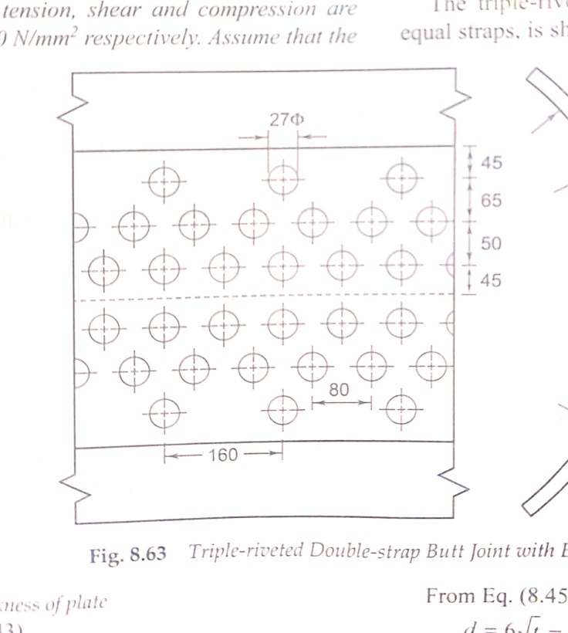
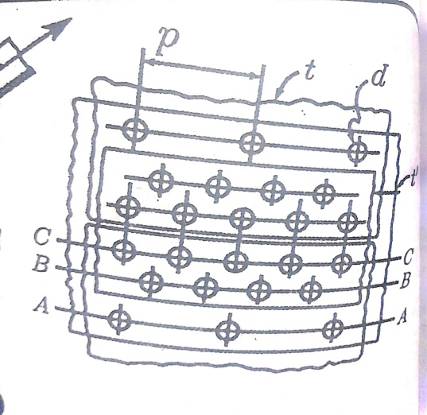

Number of rivets per pitch
Outer row: 1, Middle row: 2, inner row: 2
As per the given conditions there are 5 rivets per pitch length and since the straps are of equal width, all the rivets are in double shear

Optimum pitch
$p=\frac{\left(n_{1}+1.875n_{2}\right)πd^{2}τ}{4tσ_{t}}+d$ Eqn 5.12(a) /Pg.81
For equal cover butt joint n₁ =0
$$p=\frac{\left(1.875n_{2}\right)πd^{2}τ}{4tσ_{t}}+d=\frac{\left(0+1.875×5\right)π{\left(28.5\right)}^{2}×60}{4×20×80}+28.5=252.8 mm$$

- Maximum pitch, $p_{max}=k_{1}t+41 mm$ Eqn5.12 (b) /Pg.81
Where k₁ = a constant (Table 5.4(a)/Pg.85
From Table 5.1/Pg. 84, for double row butt joint with two cover plates, No.of rivets per pitch = 5. From Table 5.4(a)/Pg. 85, For 5 nos of rivets per pitch, the coefficient, k₁ for double butt strapped joints = 6
$$p_{max}=k_{1}t+41 mm=6×20+41 =161$$
Since p_{max} is less than the calculated value the pitch of the joint p = 161 or 160 mm.

For leak free joint$p ≤6d$
$\frac{160}{28.5}=5.61 <6$ Eqn5.12 (d)/Pg.82
Hence the joint is leak proof
- Transverse pitch (distance between the rows of rivet)
The transverse pitch for joints where the longer pitch is double the shorter ones and the inner rows are staggered (zig- zag) riveted

${ p}_{t}≥0.2p+1.15d$ Eqn5.15 (a)/Pg.82

${ p}_{t}≥0.2×160+1.15×28.5=64.78 mm\sim 65 mm$

- Transverse pitch between the successive inner rows
${ p}_{t}≥0.165 p+0.67d$ Eqn5.15 (a)/Pg.82

- Thickness of the cover straps
Thickness of double butt straps of equal width having every alternate rivet in the outer rows are omitted Eqn5.4 (d)/Pg.82
$$t_{i}=t_{0}=0.625 \left(\frac{p-d}{p-2d}\right)t=0.625×20×\left(\frac{160-28.5}{160-2×28.5}\right)=15.95\sim 16 mm$$
- Margin, m
$$m=1.5 d=1.5×28.5=42.75 mm=43 mm$$
- Efficiency
$$η=\frac{least value of P_{t},P_{s} and P_{c}}{P}$$
- Tearing efficiency $η_{t}=\frac{p-d}{p}=\frac{160-28.5}{160}=82.2 \%$ Eqn5.9 (e)/Pg.81
- Shearing or rivet efficiency $η_{s}=\frac{\frac{π}{4}d^{2}\left(n_{1}+1.875n_{2}\right)τ}{ptσ_{t}}$ Eqn5.9 (f)/Pg.81
$$η_{s}=\frac{\frac{π}{4}×{28.5}^{2}\left(0+1.875×5\right)60}{160×20×80}=140\%$$
- Crushing efficiency
$$η_{c}=\frac{P_{c}}{P}$$
Where P_{c} = Resistance to crushing of rivets

${ P}_{c}=\left(n_{1}t_{i}+n_{2}t\right)dσ_{c}$ Eqn5.6 (e)/Pg.80

$$η_{c}=\frac{\left(n_{1}t_{i}+n_{2}t\right)dσ_{c}}{ptσ_{t}}=\frac{\left[0+5×20\right]28.5×120}{160×20×80}=134 \%$$

The efficiency is the least = 82.2 %

